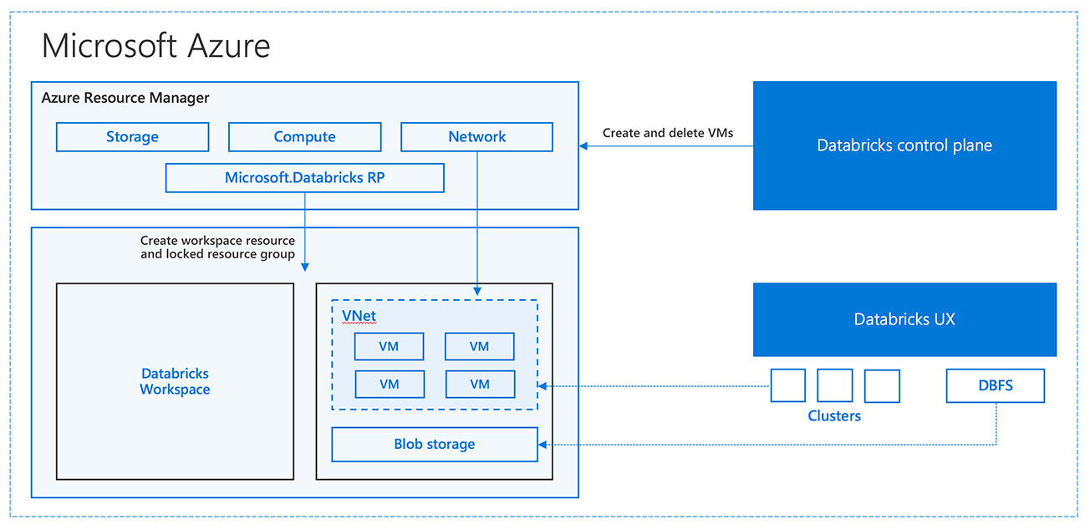

Azure Databricks is a **cloud-based data analytics and machine learning platform** that combines the best of **Apache Spark** (a powerful big data processing framework) with the **scalability and integration of Microsoft Azure**.

**key features of Azure Databricks**:

**Built on Apache Spark**: Provides distributed computing for handling large-scale data processing tasks like ETL (Extract, Transform, Load), streaming, and analytics.

**Collaborative workspace**: Offers notebooks where data engineers, data scientists, and analysts can work together in Python, SQL, R, Scala, or Java.

**Machine learning & AI**: Supports ML frameworks like TensorFlow, PyTorch, Scikit-learn, MLlib for building and deploying models.

**Data lake integration**: Works seamlessly with **Azure Data Lake Storage**, **Azure Synapse Analytics**, **Azure SQL**, **Cosmos DB**, and other Azure services.

**Scalable clusters**: Automatically scales compute clusters up/down based on workload.

**Uses of Azure Databricks:**

* **Big Data Processing**: Handle huge volumes of structured, semi-structured, and unstructured data.
* **ETL & Data Engineering**: Clean, transform, and load data from multiple sources.
* **Real-time Analytics**: Process streaming data (IoT, clickstream, logs, etc.) in near real-time.
* **Machine Learning & AI**: Train and deploy ML/AI models with built-in libraries (MLlib, TensorFlow, PyTorch).
* **Data Science Collaboration**: Data engineers, scientists, and analysts can work together in shared notebooks.
* **Business Intelligence**: Integrates with Power BI and Azure Synapse for dashboards and reports.

**Advantages of Azure Databricks:**

1. **Scalability** – Automatically scales up/down clusters based on workload.
2. **Performance** – Optimized Apache Spark runtime (faster than open-source Spark).
3. **Multi-language support** – Python, SQL, Scala, R, Java.
4. **Seamless Azure integration** – Works with Data Lake, Synapse, Cosmos DB, Blob Storage, Power BI.
5. **Collaboration** – Shared workspace and notebooks for teams.
6. **Advanced ML & AI** – Built-in support for machine learning libraries and frameworks.
7. **Security & Compliance** – Azure AD integration, role-based access, enterprise-level compliance.

**Disadvantages of Azure Databricks:**

1. **Cost** – Can get expensive if clusters are not managed properly.
2. **Complexity** – Requires knowledge of Spark and distributed computing concepts.
3. **Learning Curve** – Beginners may find it difficult to master advanced features.
4. **Cluster Management** – Even with auto-scaling, wrong configuration can lead to resource wastage.
5. **Latency for Small Jobs** – Not ideal for very small or lightweight data processing tasks (overhead cost).